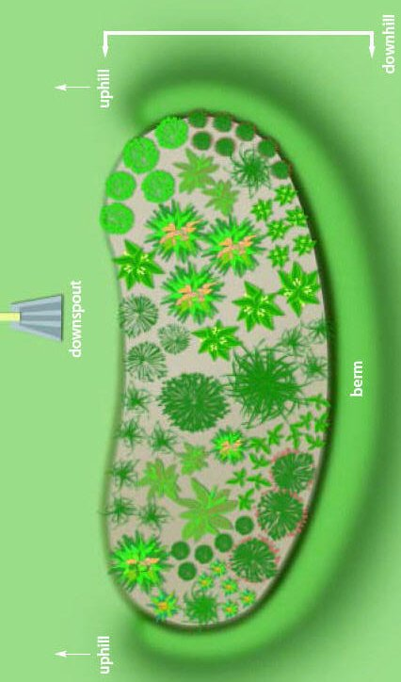C:\Users\McMahon\AppData\Local\Microsoft\Windows\Temporary Internet Files\Content.IE5\FVPVZL65\MC900325622[1].wmfC:\Users\McMahon\AppData\Local\Microsoft\Windows\Temporary Internet Files\Content.IE5\V9FYM04Q\MC900298013[1].wmf 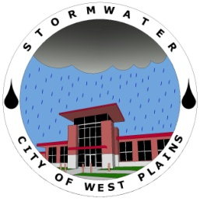

# City of West Plains Stormwater Department

## How it all Began

The Stormwater Department has been working towards building rain gardens across the city. The goal is to have a few more in place during the coming year.

A few possible locations for the future rain gardens include the Welcome Center and the Georgia White Walking Park. By collecting the runoff from the parking lot at these two locations the quality of the stormwater leaving these sites will be improved.

The stormwater map continues to be updated with new information to better track any illicit discharges.

The Stormwater Department has issued three permits this year. These permits are monitored using the procedures outlined in the Stormwater Management Volume 1. Monitoring includes checking BMP’s for proper maintenance and insuring there is minimal sediment tracking from the site.

If you see any sites with poor maintenance or a large amount of tracking onto city streets you can contact the Stormwater Hotline at (417) 256-7170 Ext. 234

For more information on upcoming projects feel free to contact City Hall at (417) 256-7170 or by email at [stormwater@westplains.net](mailto:stormwater@westplains.net)

You can also visit the stormwater website for updates at

wpstormwater.weebly.com

Inside this issue:

Rain Gardens 2

Rain Barrels 2

Tree City USA 3

Benefits of Trees 3

Noteworthy Trees 3

Recycling 4

Volume 2, Issue 1

January 2012

STORMWATER NEWS

### Recent Projects

In 1969 the pollution of the Cuyahoga River reached once again extreme levels. On June 22, 1969 the Cuyahoga River erupted into flames. This event brought attention to a growing problem and spurred action that led to many environmental programs such as the Clean Water Act.

The Federal Clean Water Act of 1972 requires that stormwater discharges from certain types of facilities be authorized under stormwater discharge permits. The goal of the stormwater permits program is to reduce the amount of pollutants entering streams, lakes and rivers as a result of runoff from residential, commercial and industrial areas.

The original 1990 regulation (Phase I) covered municipal storm sewer systems for municipalities with populations equal to or greater than 100,000.   
  
The regulation was expanded in 1999 to include municipalities with populations of 10,000 or more. This expansion of the program is referred to as Phase II.

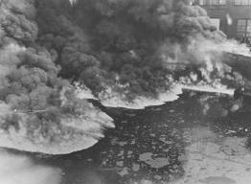

Special points

of interest:

* Rain Gardens
* Tree City
* Mulching Leaves
* Recycling

Rain Gardens are a great way to improve the landscape around your home. With the improved filtration the quality of water will increase making a positive impact on the environment.

The purpose of a rain garden is to catch rain water and allow it to absorb into the ground. This filters the water and improves the quality of the water leaving the property. Not only is this process good for the environment but it will also decrease demands on water treatment facilities.

When building a rain garden placement is very important, however, the size of the rain garden will have a lot to do with where it can go.

It is important that the rain garden is at least 10 feet from the house. This will help prevent water from the garden getting into the foundation.

It’s best to put the rain garden in full or partial sunlight.

The flatter the area the easier it will be to install the rain garden.

Avoid placing a rain garden over a septic system.

Areas where water ponds, should be avoided because rain gardens encourage infiltration and areas that pond indicate poor infiltration.

A couple of plants about two years old will help get things started. Be sure and use nursery-propagated plants not wild ones.

Plants native to the region will have the best chance of survival. These plants will also provide good filtration and allow for a more effective rain garden.

Having a good idea where to place plants will help make the process go smoother.

Placing labels will allow for easier identification which will help when it comes time to remove weeds.

Keeping weeds out of the rain garden is important to having a stable rain garden. Pruning is the best way to remove weeds. If any chemicals are being used they will pollute the stormwater passing through the rain garden.

**“It’s best to put the rain garden in full or partial sunlight.”**

Page 2

## Rain Gardens

STORMWATER NEWS

### Rain Barrels

If you like to garden or water plants then a great way to save on water and still give them the water they need is a rain barrel.

Rainwater can be collected from rooftops in mosquito proof containers. The water can then be used later on lawn or garden areas as well as washing vehicles.

The water used by collecting rainfall could save as much as 1,000 gallons of water.

That is 1,000 gallons that didn’t have to be treated and was completely free.

By catching the water in rain barrels the amount of stormwater runoff is also decreased which could help with flash floods as well as keep the impact on the environment lower.

The City of West Plains is working towards becoming a Tree City. There are four standards for becoming a Tree City.

1. Tree Board
2. Tree Care Ordinance
3. Community Forestry Program
4. Arbor Day Observance and Proclamation

The first standard has been met with the current tree board consisting of 5 members from the community. One of the goals of the Tree Board is to do a tree survey to help monitor the trees in the City. This will allow for better tree maintenance and to insure diseased trees are removed before other trees can be affected.

The second standard requires a tree ordinance to be in place, the City Council accepted the tree ordinance on December 21st 2009. The ordinance outlines what trees the City will plant and how trees will be maintained.

The third standard covers all the work the City does when planting, pruning and removing trees in the city.

The fourth standard involves having an Arbor Day event. This year an Arbor Day event was held at Galloway Park on April 30th. With the help of the Boy Scouts, 26 trees were planted.

The Tree Board would like to try creating a map of interesting trees around the City of West Plains.

The hope is to find trees that have interesting characteristics such as shape, age, rarity, and history.

The Tree Board can use the information collected to create both a map and a brochure covering these noteworthy trees.

If you know of any noteworthy trees feel free to contact City Hall at (417) 256-7170 or email at

[stormwater@westplains.net](mailto:stormwater@westplains.net)

STORMWATER NEWS

### Noteworthy Trees

## TREE CITY USA

## Benefits of Trees

Page 3

**“With the extra nutrients given by the mulched leaves your yard will look better and healthier”**

Trees have many benefits ranging from environmental to economical.

Trees are a great way to lower heating costs in the winter by keeping cold winds at bay. They lower cooling costs in the summer by providing shade, and add value to your house with the landscape.

The environmental benefits of trees include habitats for wildlife, improved carbon dioxide absorption, and oxygen production.

Some may say that the leaves from many trees are a nuisance because of clogged ditches and covered yards.

Mulching the leaves that fall from the trees allows their nutrients be absorbed into the ground you can greatly improve the health of your lawn.

With the leaves out of the ditches water will have an easier time of flowing and can reduce the risk of flooding.

With the extra nutrients given by the mulched leaves your yard will look better and healthier.

A great resource for tree information is the website www.arborday.org

The West Plains Recycling Center has a program that allows city residents to recycle with minimal effort. The City uses red fourteen gallon recycling bins for people to place their recyclables in. On trash day set your red recycle bin next to your trash can for pick up.

**ITEMS BANNED FROM THE LAND FILL**By Missouri Senate Bill 530: Tires, Yard Waste, Batteries, Motor Oil, Household Hazardous Waste, White Goods  
  
**Tires accepted for a fee:** $1.25 per car tire  
$5.00 per semi tire

Recyclable items are grouped into **five categories**:

**Glass and Aluminum**

**Steel**

**Tin Cans**

**Plastics**

**Paper**

For any comments or concerns about the West Plains Recycling program contact the Sanitation Department at: (417) 255-2330

Or you can access the Recycling Center page on the website at:

http://wpstormwater.weebly.com/recycling-center.html

**Stormwater department**

1910 Holiday Lane

West Plains, Mo 65775

Phone:

(417) 256-7170

E-Mail:

stormwater@westplains.net

We’re on the Web!

*See us at:*

wpstormwater@weebly.com

## Interested in Recycling?

**STORMWATER NEWS**

Page 4