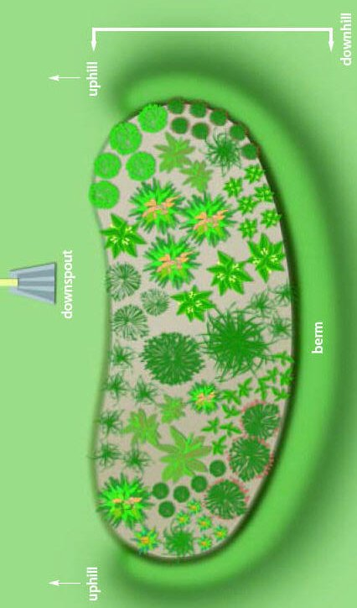C:\Users\McMahon\AppData\Local\Microsoft\Windows\Temporary Internet Files\Content.IE5\FVPVZL65\MC900325622[1].wmfC:\Users\McMahon\AppData\Local\Microsoft\Windows\Temporary Internet Files\Content.IE5\V9FYM04Q\MC900298013[1].wmfC:\Program Files (x86)\Microsoft Office\MEDIA\CAGCAT10\j0298897.wmf 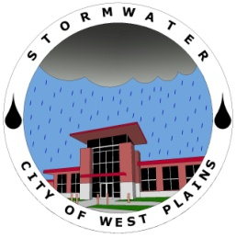

# City of West Plains Stormwater Department

## What Is Stormwater?

The Stormwater Department has been working towards a few different projects. One such project can be seen out at Galloway Park. Drainage work has been done to help clean and remove sediment and debris from the water that flows through the bridge on county road 1770. This drainage way will help to improve the water quality as well as keep harmful pollutants out of the creek.

Another project being worked on is a stormwater map of the City that will allow the Stormwater Department to better track water issues as well as monitor illicit discharge.

This map will also be used to assist in the stenciling of storm boxes by allowing for better planning and tracking of what boxes have already been stenciled and those that still need to be.

The City of West Plains has recently passed both a Land Disturbance Ordinance and an Illicit Discharge Ordinance. These give the city the means to both monitor and ensure that activities within the city will not have a negative impact on the local water bodies.

For more information on upcoming projects feel free to call City Hall at (417) 256-7170 or by email at [stormwater@westplains.net](mailto:stormwater@westplains.net)

You can also visit the stormwater website for updates at

wpstormwater.weebly.com

Inside this issue:

Rain Gardens 2

Rain Barrels 2

Icy Roads 3

Leaves 3

Stream Cleanups 3

New Website 4

Recycling 4

Volume 1, Issue 1

January 2011

STORMWATER NEWS

### Recent Projects

Stormwater runoff occurs when precipitation from rain or snowmelt flows over the ground. Impervious surfaces like driveways, sidewalks, and streets prevent stormwater from naturally soaking into the ground.

Stormwater can pick up debris, chemicals, dirt, and other pollutants and flow into a storm sewer system or directly to a lake, stream, river, wetland, or coastal water. Anything that enters a storm sewer system is discharged untreated into the water bodies we use for swimming, fishing, and providing drinking water.

Polluted stormwater runoff can have many adverse effects on plants, fish, animals, and people.

* Sediment can cloud the water and make it difficult or impossible for aquatic plants to grow.
* Sediment also can destroy aquatic habitats.
* Bacteria and other pathogens can wash into swimming areas and create health hazards, often making beach closures necessary.
* Polluted stormwater often affects drinking water sources. This, in turn, can affect human health and increase drinking water treatment costs.
* The quality of stormwater is also greatly affected by Illicit Discharge.
* Illicit Discharge can be defined as anything entering a storm drain that is not strictly rain water.

Special points

of interest:

* Rain Gardens
* Road Salt
* Mulching Leaves
* New Website

Rain Gardens are a great way to improve the landscape around your home. With the improved filtration the quality of water will increase making a positive impact on the environment.

The purpose of a rain garden is to catch rain water and allow it to absorb into the ground. This filters the water and improves the quality of the water leaving the property. Not only is this process good for the environment but it will also decrease demands on water treatment facilities.

When building a rain garden placement is very important. Depending on the size of the rain garden will have a lot to do with where it can go.

It is important that the rain garden is at least 10 feet from the house. This will help prevent water from the garden getting into the foundation.

It’s best to put the rain garden in full or partial sunlight.

The flatter the area the easier it will be to install the rain garden.

Avoid placing a rain garden over a septic system.

Areas where water ponds should be avoided because rain gardens encourage infiltration and areas that pond show that infiltration is low.

A couple of plants about two years old will help get things started. Be sure and use nursery-propagated plants not wild ones.

Plants native to the region will have the best chance of survival. These plants will also provide good filtration and allow for a more effective rain garden.

Having a good idea where to place plants will help make the process go smoother.

Placing labels will allow for easier identification which will help when it comes time to remove weeds.

Keeping weeds out of the rain garden is important to having a stable rain garden. Pruning is the best way to remove weeds. If any chemicals are being used they will pollute the stormwater passing through the rain garden.

**“It’s best to put the rain garden in full or partial sunlight.”**

Page 2

## Rain Gardens

STORMWATER NEWS

### Rain Barrels

If you like to garden or water plants then a great way to save on water and still give them the water they need is a rain barrel.

Rainwater can be collected from rooftops in mosquito proof containers. The water can then be used later on lawn or garden areas as well as washing vehicles.

The water used by collecting rainfall could save as much as 1,000 gallons of water.

That is 1,000 gallons that didn’t have to be treated and was completely free.

By catching the water in rain barrels the amount of stormwater runoff is also decreased which could help with flash floods as well as keep the impact on the environment lower.

Ever see litter or debris being carried down the street when it rains? Well all of that debris will eventually end up in local waterways and streams and then be carried down creeks and rivers polluting them with all the trash carried by stormwater runoff.

A great way to help prevent further pollution is by participating in stream cleanups. The goal of a stream cleanup is to remove all of the debris, trash and litter carried into a creek or stream preventing it from being washed further down and therefore stopping any further pollution.

If you would be interested in stream cleanups or would like to know more feel free to contact City Hall at

(417) 256-7170 or email at [stormwater@westplains.net](mailto:stormwater@westplains.net)

STORMWATER NEWS

### Stream Cleanups

## Icy Roads

## Free Fertilizer for a Better Looking Lawn

Page 3

**“With the leaves out of the ditches water will have an easier time of flowing and can reduce the risk of flooding.”**

With leaves on the ground it is very tempting to just rake them into a ditch and let them be. However, how about a solution that will both enhance your yard and keep the drainage ways clean.

By mulching the leaves that fall from the trees and letting their nutrients be absorbed into the ground you can greatly improve the health of your lawn.

With the leaves out of the ditches water will have an easier time of flowing and can reduce the risk of flooding.

A great way to mulch leaves is to take a lawn mower over your lawn and just letting the cut up leaves stay where they fall. By cutting them to smaller pieces the ground is better able to absorb the nutrients the leaves have to offer without risk of killing your grass.

With the extra nutrients given by the mulched leaves your yard will look better and healthier.

Winter is here and that means icy road conditions. With that come snow plows and a great deal of salt.

The extra salt on the ground not only helps break up the ice but when it gets washed down the streets can also affect the water quality and wildlife in the streams.

Salt wont only hurt the streams it also has corrosive properties that could do minor damage to vehicles as well.

A great way to keep the damage minimal is to take your vehicle through a car wash just to keep everything rinsed off so the salt can’t sit and begin the corrosive process.

The salt will be drained into the car washing facility and there it can be filtered before entering local waterways.

This will also help prevent vehicles from transporting the salt to an area where it could damage the local environment.

Recyclable items are grouped into **five categories**:

**Glass and Aluminum**

**Steel**

**Tin Cans**

**Plastics**

**Paper**

For any comments or concerns about the West Plains Recycling program contact the Sanitation Department at: (417) 255-2330

Or you can access the Recycling Center page on the website at:

http://wpstormwater.weebly.com/recycling-center.html

The West Plains Recycling Center has a program that allows city residents to recycle with no extra effort. The City uses red fourteen gallon recycling bins for people to place their recyclables in. On trash day set your red recycle bin next to your trash cans for pick up.

**Stormwater department**

1910 Holiday Lane

West Plains, Mo 65775

Phone:

(417) 256-7170

E-Mail:

stormwater@westplains.net

We’re on the Web!

*See us at:*

wpstormwater@weebly.com

### Interested in Recycling?

Recently the Stormwater Department has finished putting together a stormwater website for the City of West Plains.

The website is a great way to learn more about the Stormwater program and the different projects the Stormwater Department is working on.

The site explains in detail what the Stormwater program is all about such as the goals of the program how it was started and things to come.

There is also a survey that can be filled out with any questions, comments or concerns.

The Web Site can be visited at:

wpstormwater.weebly.com

Or you can email:

[stormwater@westplains.net](mailto:stormwater@westplains.net)

## New Website

clock

**STORMWATER NEWS**

Page 4